**LAPORAN PRAKTEK TOPIK KHUSUS**

**INSTALASI REDIS**

**DISUSUN OLEH:**

**KHAIRUL RACHMAN**

**2211083007**

**TEKNOLOGI INFORMASI**

**TEKNOLOGI REKAYASA PERANGKAT LUNAK**

**POLITEKNIK NEGERI PADANG**

**2025**

**LANGKAH KERJA**

**1.Menginstall**

-GO

-MYSQL

-Redis

-Postman

**2.Setup Database**

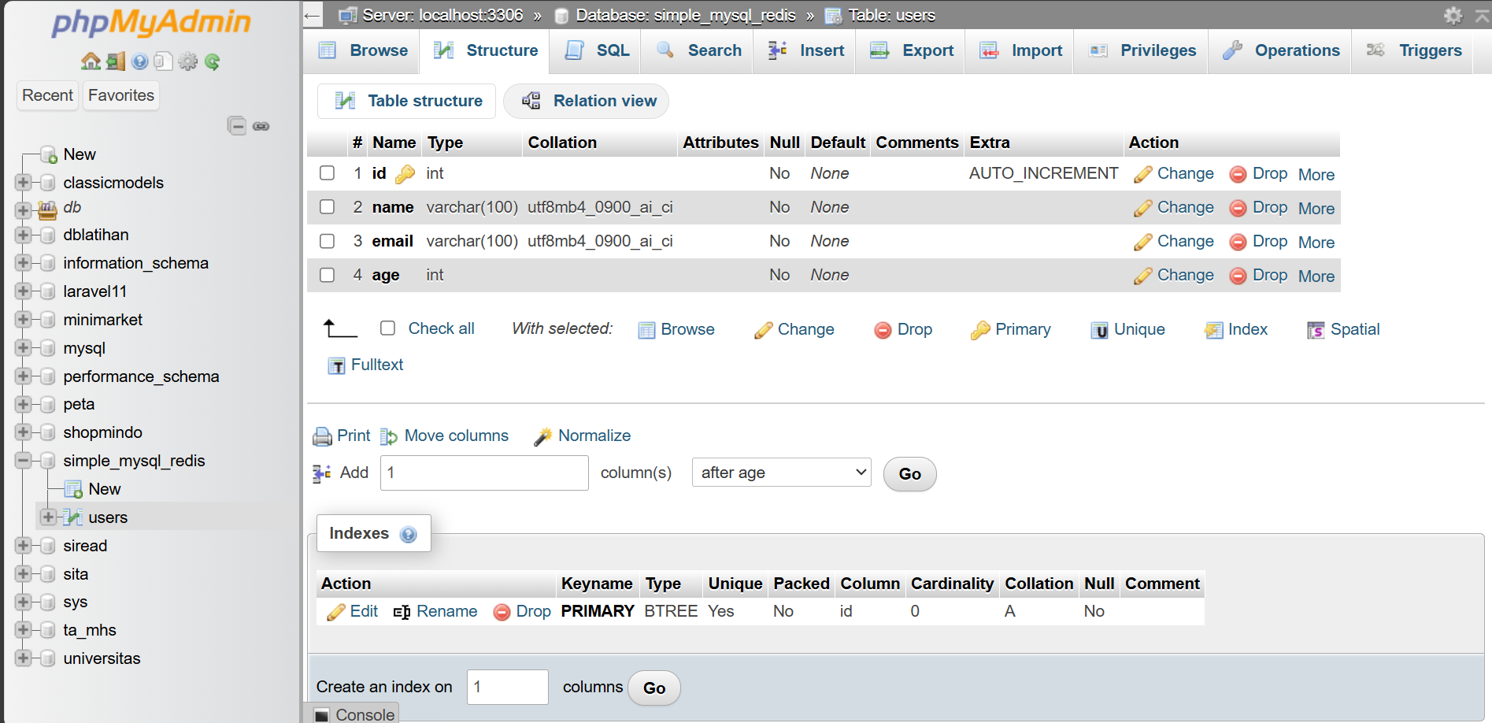

**3.Clone Repository**

git clone https://github.com/kusnadi8605/simple_mysql_redis.git

cd simple_mysql_redis

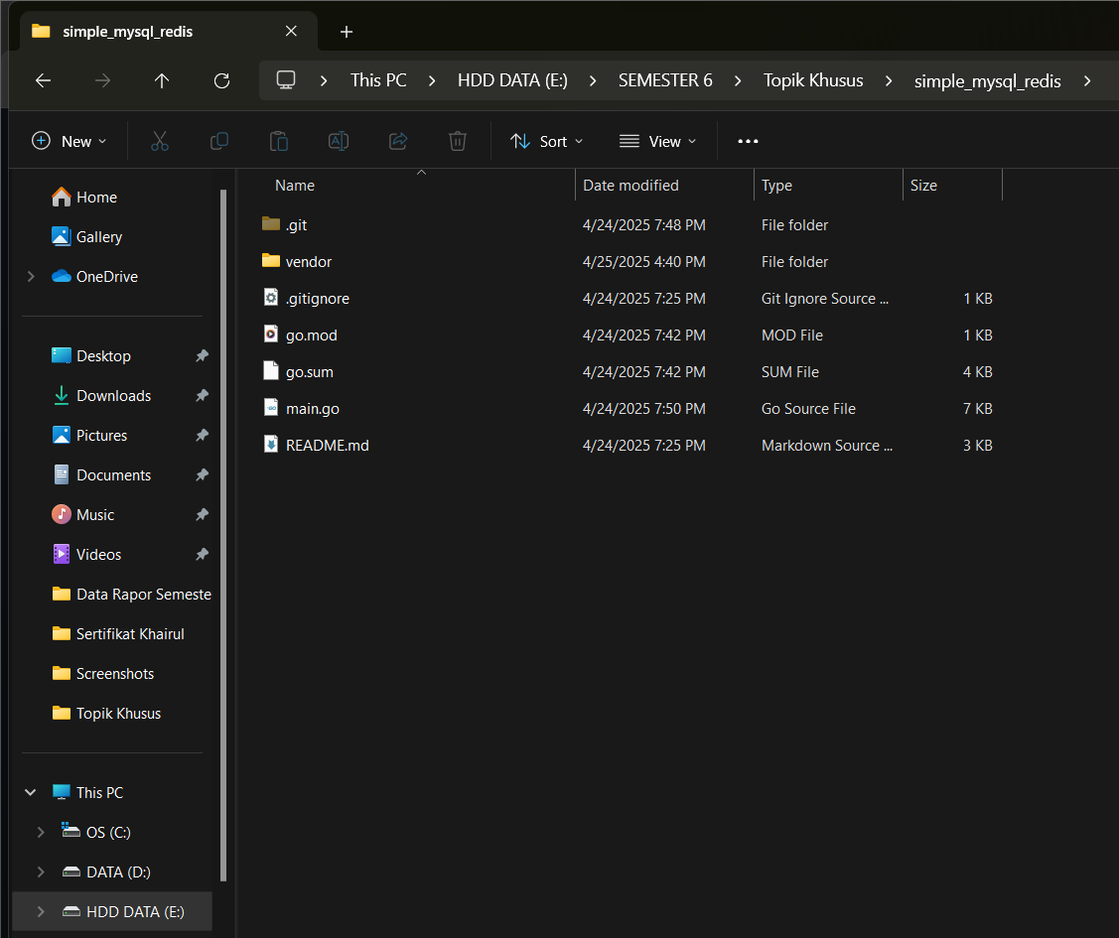

**4.Konfigurasi Enviroment**

Sesuaikan konfigurasi DB dan Redis

**5.Install Dependencies**

go mod init simple_mysql_redis

go mod tidy

go mod vendor

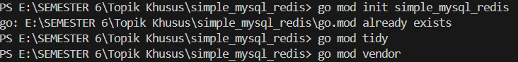

**6.Jalankan Server**

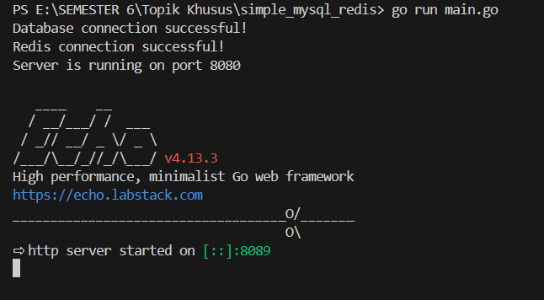

**7. Api Endpoints dan cURL Commands**

**1.Create User**

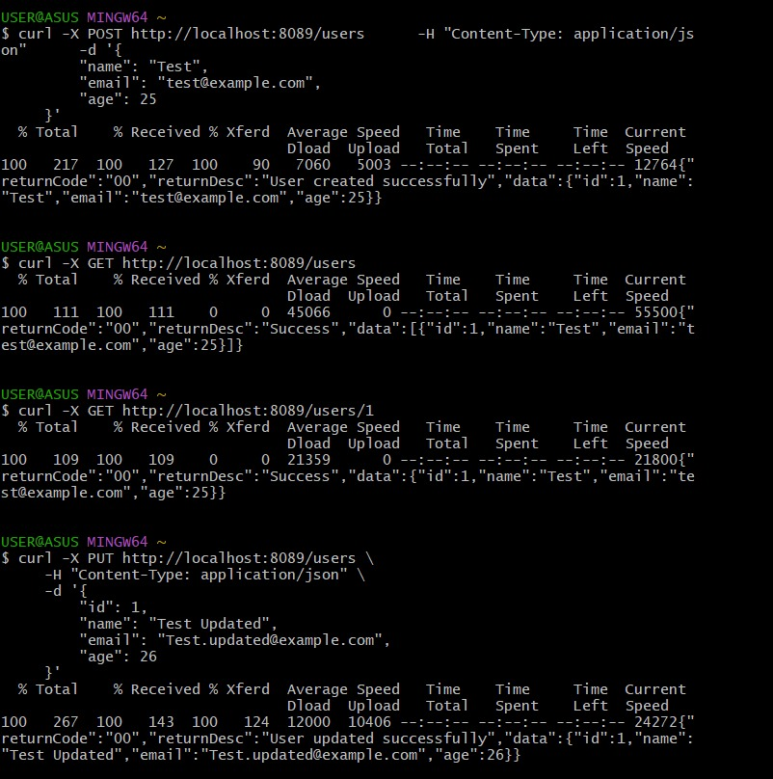

**2. Get All Users**

curl -X GET http://localhost:8089/users

**3. Get Single User**

curl -X GET <http://localhost:8089/users/1>



**4.Update User**

curl -X DELETE http://localhost:8089/users/1



**5. Delete User**

curl -X DELETE <http://localhost:8089/users/1>

